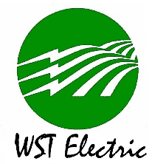
WASHINGTON - ST. TAMMANY
ELECTRIC COOPERATIVE, INC.

APPLICATION FOR WST ELECTRIC YOUTH TOUR

Return To: Washington-St. Tammany Electric Cooperative
Attn: Coylean Schloegel
P.O. Drawer 697
Franklinton, LA 70438

NAME: _______________________________________ AGE AS OF 1/1/2024: ____________

MAILING ADDRESS: __________________________________________________________
Street or Box City/State Zip

PARENTS NAME: __________________________________ PHONE #: _________________

NAME ON WST ACCOUNT or ACCOUNT #: ______________________________________

RETURN BY February 23, 2024 WITH YOUR ESSAY BASED ON: (800 WORDS OR LESS) “What Would The World Be Like Without Electricity?”

